**EXERCISE: 04**

**DATE: 23.11.2020**

**AIM:**

To write a python program to print a single string from two sets of strings received from user and swap the first two characters of each string

**PROGRAM:**

**def convert(s):**

**new=""**

**for x in s:**

**new+=x**

**return new**

**a=input()**

**b=input()**

**s1=a.strip()**

**s2=b.strip()**

**if(len(s1)>=2 and len(s2)>=2):**

**t1=list(s1)**

**t2=list(s2)**

**c1=t1[0]**

**c2=t1[1]**

**t1[0]=t2[0]**

**t1[1]=t2[1]**

**t2[0]=c1**

**t2[1]=c2**

**s1=convert(t1)**

**s2=convert(t2)**

**print(s1," ",s2)**

**else:**

**print("Invalid")**

**LINK:**

[**http://103.53.53.18/mod/vpl/forms/submissionview.php?id=234&userid=1664**](http://103.53.53.18/mod/vpl/forms/submissionview.php?id=234&userid=1664)

**OUTPUT:**

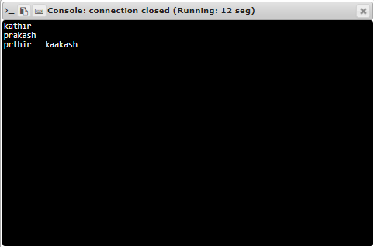

**RESULT:**

Thus the program is executed successfully